EXERCISE-26

26.Design TM using simulator to accept the input string Palindrome bbabb

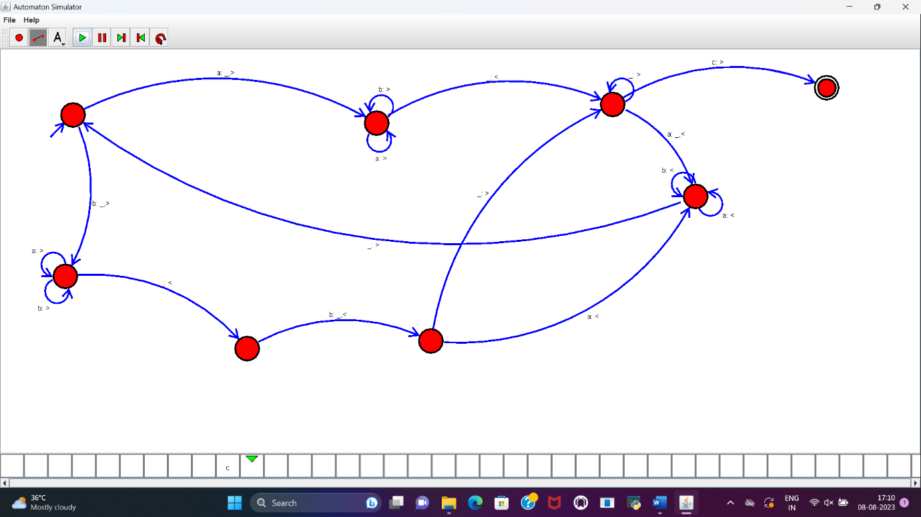

RESULT:

TM to accept the input string palindrome bbabb is designed and implemented successfully.